Adityaprava Sen

CSE 2nd Year

Roll-56

Assignment on Lists Outputs

Question 1-3:

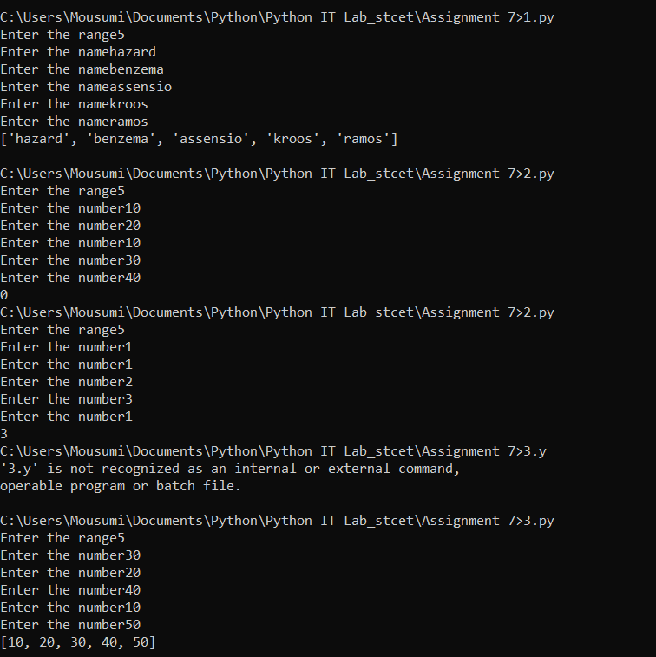

Questions 4-6:

